Guide 2. APT Project Development
Capstone Course

1. APT Project Progress Summary
Below you will find several fields that you must complete with the requested information.

APT Project Progress Summary | Vexa Local arises from the needs of a team of lawyers: organizing case files and allowing each person in charge to consult their documentation without reviewing file by file. In this phase, the project moved from the definition stage (Phase 1) to a functional, 100% local desktop prototype, with an AI assistant that answers questions about the documents of a case and shows the sources used.  Specific objectives achieved so far  • Technology selection (Obj. 1): Ollama was defined (Llama 3.2 for generation and optional bge-m3 for embeddings), BM25 for lexical retrieval, Flask + SQLite as the local backend, and Electron for the desktop window.  • Ingestion and processing (Obj. 2): text is extracted from PDF, DOCX, XLSX, PPTX, TXT and CSV files (30 MB limit per file), with optional OCR via Tesseract. The text is split into chunks and indexed in the background; a content hash avoids reprocessing files that have not changed.  • Retrieval (Obj. 3): BM25 finds matches by words, names and numbers; the optional semantic search (bge-m3) finds chunks by meaning, and both results are combined before the context is sent to the model.  • Conversational interface (Obj. 4): web interface inside Electron with an administrator view (accounts, teams, cases, document upload and assignment) and a lawyer view (assigned cases and chat with progressive responses and references to the sources).  • Security and privacy (Obj. 5, progress): the backend listens only on 127.0.0.1; passwords are stored as hashes; administration routes are restricted by role; access to each case is granted only if it is assigned directly to the lawyer or to a team they belong to; document content is encrypted at rest.  • Packaging: configuration to generate the Windows installer with PyInstaller and electron-builder/NSIS.  Compared with Phase 1, the system grew in scope: case management with deadlines, teams, a watched folder to incorporate new files, and automated tests with pytest were added. The formal privacy verification (network traffic analysis) and the evaluation of accuracy and response times (Obj. 5 and 6) remain in progress, detailed in section 3.
Objectives | The general objective of Phase 1 is maintained (a RAG system that operates 100% locally for organizations with sensitive data), but its application was adjusted to a specific use case: a law firm that assigns case files to lawyers and teams.  • Objective 2 is expanded: from “PDF and Word” to six formats (PDF, DOCX, XLSX, PPTX, TXT and CSV) with optional OCR.  • Objective 3 is expanded: from lexical-only retrieval (BM25) to hybrid retrieval (BM25 + optional semantic search with bge-m3).  • Objective 4 is expanded: the interface incorporates roles (administrator and lawyer), cases, teams and assignment, instead of a single PIN access.  • Objectives 5 (privacy verification through traffic analysis) and 6 (evaluation of accuracy and response times) remain unchanged.
Methodology | The agile Scrum methodology with DevOps practices defined in Phase 1 is maintained (short iterations with functional modules, GitFlow with main/develop/feature branches, and a Kanban board), supported by CRISP-DM for understanding the problem, preparing test documents and evaluating the RAG system.  Adjustment: progress was organized by integrable components (ingestion → indexing → retrieval → generation → interface → security → packaging), testing each module before joining it to the next.
Evidence of progress | Evidence presented  • Prototype source code (GitHub repository): backend (web_app.py, store.py, vault.py), RAG engine (rag_hybrid.py, rag_stages.py, rag_core.py), format reading (formats.py), watched folder (watcher.py) and Electron application (main.js). It directly shows the implementation of case management, permissions, ingestion, hybrid retrieval and chat with sources.  • Automated tests (pytest) and functional tests with synthetic documents, without real client data.  • Screenshots of the application in operation (administrator view, lawyer view and chat with references).  Lawyer view  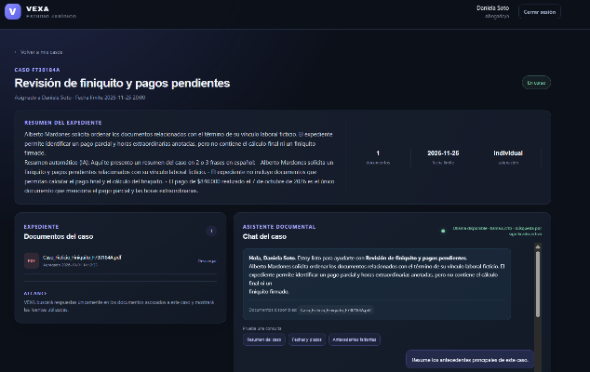  Administrator view:  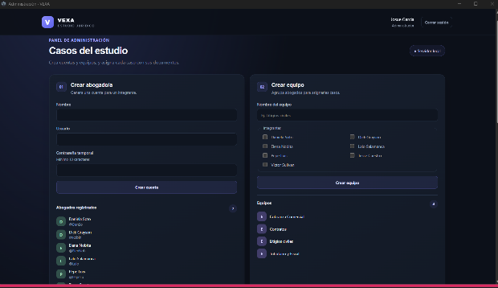  Chat with Reference  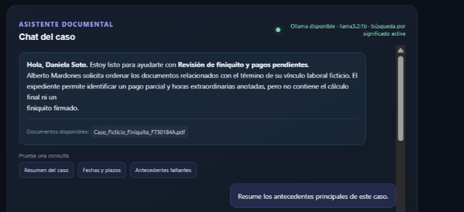  • Phase 2 reflection journal and Phase 1 documents (definition, work plan and Gantt Chart), which make it possible to compare what was planned with what was executed.  Quality assurance  Quality was safeguarded with practices specific to computer engineering: version control with GitFlow and integration review between branches, separation of responsibilities by module, automated tests, application of the principle of least privilege (role + assignment per case), encryption of content at rest, and local execution without external services. Responses are limited to the retrieved content and always include the source, which allows them to be verified.
2. Work Plan Monitoring
Carefully examine your work plan, focusing especially on the progress status and adjustments column.

Work Plan
Competency or competency units | Activities | Resources | Duration of the activity | Person in charge | Observations | Progress status | Adjustments
Analysis and evaluation of IT solutions | Research and selection of technologies (local LLM, embeddings, retrieval, desktop framework) | Technical documentation; Ollama; personal computers | Phase 1 (W1-W4) | Everyone | ChromaDB/Streamlit/Docker were discarded in favor of Electron + Flask + SQLite; BM25 as a base due to its low computational cost. | Completed | Change of stack compared to the original plan.
Software development | Architecture design and local environment setup | Python, Flask, Electron, GitHub, Kanban | W5-W6 | Héctor Schulz | Local backend on 127.0.0.1; GitFlow with feature branches. | Completed | PyWebView/Tkinter was replaced by Electron.
Data mining and NLP | Test dataset and validation questions | Synthetic documents (fictitious contracts and records) | W5-W6 | Ignacio López | No real data is used. | Completed | —
Data mining and NLP | Document ingestion: text extraction, chunking and optional OCR | pdfplumber, python-docx, openpyxl, python-pptx, Tesseract | W6-W8 | Ignacio López | 30 MB limit; background processing; hash to reuse results. | Completed | Expanded from PDF/Word to 6 formats.
Data mining and NLP | Hybrid retrieval: BM25 + optional semantic search (bge-m3) | Rank-BM25, Ollama, numpy | W8-W10 | Ignacio López | The semantic part is optional depending on the computer and installed models. | Completed | Changed from lexical-only to hybrid.
Software development | RAG pipeline: context, prompts, streaming response and source citations | Ollama (Llama 3.2), Flask | W9-W11 | Ignacio López | Iterative prompt tuning; quality depends on hardware and model. | Completed | —
Software development | User, role, team and case management (deadlines, assignment) | Flask, SQLite | W9-W12 | Héctor Schulz and Ignacio López | No external notifications or calendar. | Completed | Replaces the single PIN from Phase 1.
Software development (UX/UI) | Administrator, lawyer and chat interface | HTML, CSS, JavaScript, Flask templates | W9-W13 | Josué García | Progressive response and visible sources. | Completed | —
Cybersecurity and risk management | Authentication with hashing, role-based and assignment-based control, encryption at rest | cryptography, SQLite | W10-W13 | Héctor Schulz | Metadata (file names, case titles) not encrypted. | Completed | Scoped as prototype-level protection.
Software development | Electron application and watched folder for file intake | Electron, custom watchdog (watcher.py) | W12-W14 | Héctor Schulz and Josué García | Data in %USERPROFILE%\.vexa_local. | Completed | —
Software development | Packaging and installer for Windows | PyInstaller, electron-builder/NSIS | W13-W15 | Héctor Schulz | Does not include Ollama models. | In progress | Still needs to be tested on different computers.
Quality and testing | Automated tests (pytest) and functional tests | pytest, synthetic dataset | W11-W15 | Everyone | Coverage of permissions, formats and retrieval. | In progress | —
Cybersecurity and risk management | Privacy verification: network traffic analysis | Wireshark / capture tools | W15-W16 | Héctor Schulz and Ignacio López | Key evidence for the 100% local argument. | Not formally started | A documented methodology still needs to be defined.
Analysis and evaluation of IT solutions | Evaluation of accuracy and response times | Test dataset, metrics | W15-W16 | Ignacio López | Depends on model and hardware. | Pending | Define metrics with the instructor.
Project management | Final report and presentation | Duoc UC templates, PowerPoint | W16 | Everyone | — | In progress | —

3. Adjustments based on monitoring
Take a closer look at the observations in your work plan. Analyze the planned activities and point out which aspects facilitated or hindered the execution of the plan. Explain how you addressed and/or will address the obstacles. Finally, indicate the adjustments you made to the work plan based on this analysis.

Factors that have facilitated and/or hindered the development of my work plan:
Facilitators:
• Clear division of roles: Héctor Schulz (leadership, integration, packaging and security), Ignacio López (backend and AI/RAG) and Josué García (frontend and UX/UI).
• Use of stable, well-documented open-source libraries and tools (Flask, Electron, SQLite, Ollama, Rank-BM25).
• Version control with GitHub (GitFlow) and a Kanban board, which allowed modules to be integrated without major conflicts.
• Preprocessing with content hashing, which avoids re-extracting and re-indexing the same files on every query.
Difficulties and actions:
• Local model performance: the quality and speed of responses depend on the hardware and the installed model. This was mitigated with lightweight models (Llama 3.2), BM25 lexical retrieval that does not require a GPU, and semantic search as optional only; only the relevant chunks were sent to the model.
• Dependence on Ollama: the VEXA installer does not include the models. Their prior installation was documented, and including a guided check at first launch remains as an improvement.
• Scope of collaboration: assignment to teams works within a single local installation; the computers of different lawyers do not share users, cases or files. This is declared as a limitation of the prototype; a multi-user network version would require a central backend and database, synchronization and additional security controls.
• Partial encryption: the content of the documents is encrypted at rest, but some metadata in SQLite (file names, case titles) is not. This is presented as a prototype protection measure and not as certification for real case files.
• Final coordination: it was agreed to establish more frequent synchronization sessions to resolve minor blockers in the final stretch.

Adjusted or eliminated activities:
The following adjustments were made with respect to the Phase 1 plan, all justified by technical feasibility and by the legal use case:
• Technology stack: ChromaDB, LlamaIndex, FastAPI, Streamlit and Docker were discarded and Electron + Flask + SQLite was adopted. Reason: an installable desktop application is simpler to distribute to non-technical users and reduces dependencies; PyInstaller and NSIS replace Docker for packaging.
• Retrieval: BM25 was kept as a base and optional semantic search with bge-m3 was added, combining both. Reason: BM25 works well with names and numbers (frequent in case files) and the semantic part improves questions phrased with other words, without becoming mandatory.
• Access control: the single PIN from Phase 1 was replaced by users with roles (administrator/lawyer) and assignment of cases to lawyers or teams. Reason: to reflect how a law firm actually works.
• Formats: expanded from PDF and Word to XLSX, PPTX, TXT and CSV, with optional OCR, because real case files include documents of different types.
• New features: case management with deadlines, watched folder and encryption at rest. No core activity was eliminated; the “temporary file delegation” from Phase 1 was absorbed by case management and preprocessing.

Activities not started or delayed:
Activities delayed or not formally started:
• Privacy verification through network traffic analysis: the architecture already operates only on 127.0.0.1 and does not call external services, but the capture and analysis still need to be formally documented. Reason: closing the main functionality was prioritized. Strategy: define a capture protocol (normal use of the system with the network monitored), run it in a test session and attach the report as key evidence.
• Evaluation of accuracy and response times: the synthetic dataset exists, but the metrics still need to be consolidated. Strategy: set a group of questions with expected answers, measure hits with the correct source and times per query, and ask the instructor which indicators to prioritize.
• Installer testing on different computers: the packaging tools were prepared, but the executable still needs to be tested on more computers. Strategy: the whole team will take part in final integration tests on machines with different resources.

If the APT Project is a group project, in this column you must indicate the name of those responsible for each task or activity. This will later allow the evaluation to be differentiated for each member.

